**Outcomes covered 2, 3 and 4**

**Assessment task instructions**

**Part 4**

**Develop and test a small program that uses standard collection classes**

Your task here is to complete the attached Address Book application.

The program is intended to store Friend Name as a key and their Address as the value.

You will need to create an appropriate instance variable for the form AddressBook to store the address entries as a key pair value where the Friend Name is the key and the Address is the value. You should use an appropriate generic standard collection class with both the key and the value stored as string objects. (Hint: Use dictionary <https://www.youtube.com/watch?v=GS8qARHaPzk>)

You should then complete the button event handler methods.

Once you have completed the implementation, you should run the attached partial acceptance test to ensure that the program behaves as expected. You should also document any errors found and how you fixed the errors.

**User interface for Address Book program**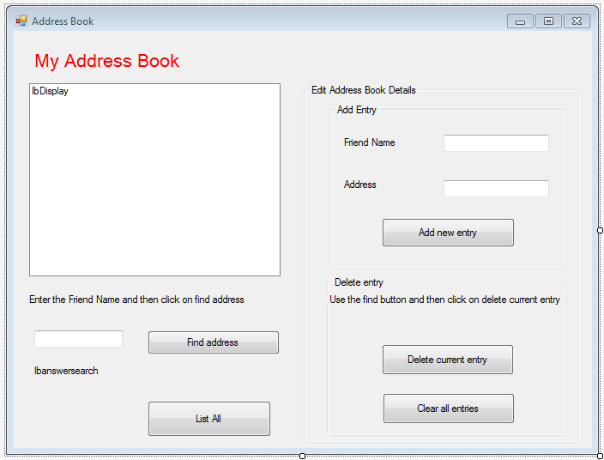

**Partial acceptance test**

This acceptance test should be run on the completed application in Debug mode to allow you to check the expected results.

|  |  |  |  |  |
| --- | --- | --- | --- | --- |
|  | **Test** | **Expected action** | **Actual action** | **Passed Y/N** |
| 1 | Click on Clear all Entries. | Should prompt for confirmation. |  |  |
| 2 | Confirm deletion. | Should clear all entries in collection. |  |  |
| 3 | Click on List All. | No entries should appear. |  |  |
| 4 | Add new entry — Friend Name John Ross and address 2 High Street Kintore. | Should prompt ‘Entry added’ and display new entry. |  |  |
| 5 | Add new entry — Friend Name Harry Watson and address 25 Townhead Street Kemnay. | Should prompt ‘Entry added’ and display new entry. |  |  |
| 6 | Add new entry — Friend Name May Evans and address 12 West Road Ellon | Should prompt ‘Entry added’ and display new entry. |  |  |
| 7 | Add new entry — Friend Name John Ross and address 89 High Road Aberdeen | Should display error message such as ‘entry with key John Ross already exists’ and clear text box showing display. |  |  |
| 8 | Click on ‘List All’. | Should display three entries |  |  |
| 9 | Enter Friend Name and then click on find address button. | Should display something similar to  May Evans, 12 West Road Ellon. |  |  |
| 10 | Click on delete current entry. | Should display something similar to entry for May Evans removed. |  |  |
| 11 | Click on ‘List All’. | Should display two entries |  |  |
| 12 | Enter May Evans and then click on find address button. | Should display something like ‘no entry with key May Evans exists’. |  |  |
| 13 | Ensure May Evans still in find address text box and then click on delete current entry. | Should display something like ‘no entry with key May Evans to remove’. |  |  |
| 14 | Exit program. | Program should exit |  |  |